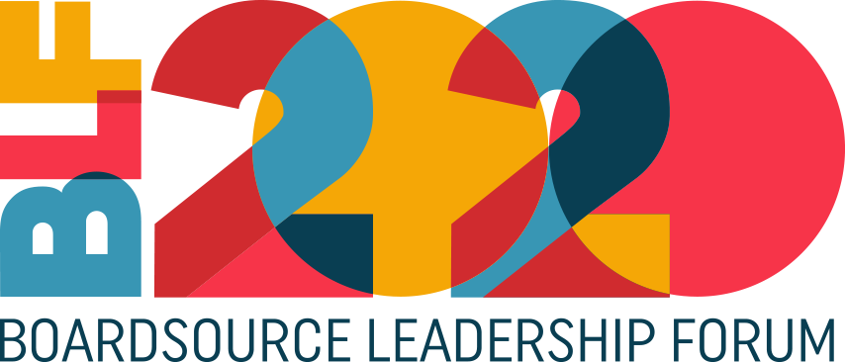

[Date]
To: [Decision-maker’s name and title]
From: [Your name and title]
Subject: 2020 BoardSource Leadership Forum
Dear [Name],
I would like to attend the 2020 BoardSource Leadership Forum, May 7 & 8 in St. Louis, MO.
The BoardSource Leadership Forum (BLF) is the largest convening of nonprofit board leaders. The event brings together more than 1000 board members, executive directors and CEOs, staff, and others who care about the health of the nonprofit sector for two days of inspiring and educational sessions focused on strengthening nonprofit leadership at the highest level — the board of directors.

Conference sessions are designed to provide solutions to the many leadership challenges in the nonprofit sector. Here are just a few of the reasons I want to attend.
- Be inspired and motivated by the many leaders who will be sharing their organizational success stories.
- Learn how to best partner with our organization’s board and support its efforts to provide exceptional leadership.
- Learn about the ways other nonprofits have successfully used collaboration to achieve their mission and increase impact.
- Learn how we can improve the effectiveness of our board meetings.
- Network with hundreds of my peers and discover how they are solving common challenges.
I can also reserve a hotel room at the conference hotel using the BLF group rate to ensure I’m staying in the center of the action and taking advantage of networking opportunities.
The opportunity to attend these sessions and discuss the challenges of the sector with hundreds of my peers makes the BoardSource Leadership Forum a wise investment for <your organization>.
I look forward to meeting with you to further discuss this opportunity.

