Module 5 Oversight & Accountability Handouts
These handouts and exercises may be used with your board to help them exercise their financial, legal and program oversight responsibilities.

Basic Questions Your Board Should Ask
Board members have a responsibility to raise questions and a right to have them answered. That does not mean that board meetings need to be taken up with questions related to minor budget details that could be answered outside the meeting. But it does mean board members should not stop asking questions for fear of offending the chief executive or anyone else.
- Is our financial plan consistent with our strategic plan?

- Have we run a gain or a loss?

- Is our projected cash flow adequate?

- Do we have sufficient reserves?

- Are any specific expense areas rising faster than their sources of income?

- Are our key expenses, especially salaries and benefits, under control?

- Are we meeting guidelines and requirements set by our funders?
Dashboards Should Convey

- information that helps the board do those things that the board is ultimately responsible for

- how we’re doing in achieving our goals as an institution

- the best practices for achieving desired outcomes

- a critical or high-risk problem in time to take corrective action

- information that may cause the board to substitute its judgment for that of staff

- a level of detail that does not invite micro-management nor masks the significance of the data

Hypothetical Governance Dashboard
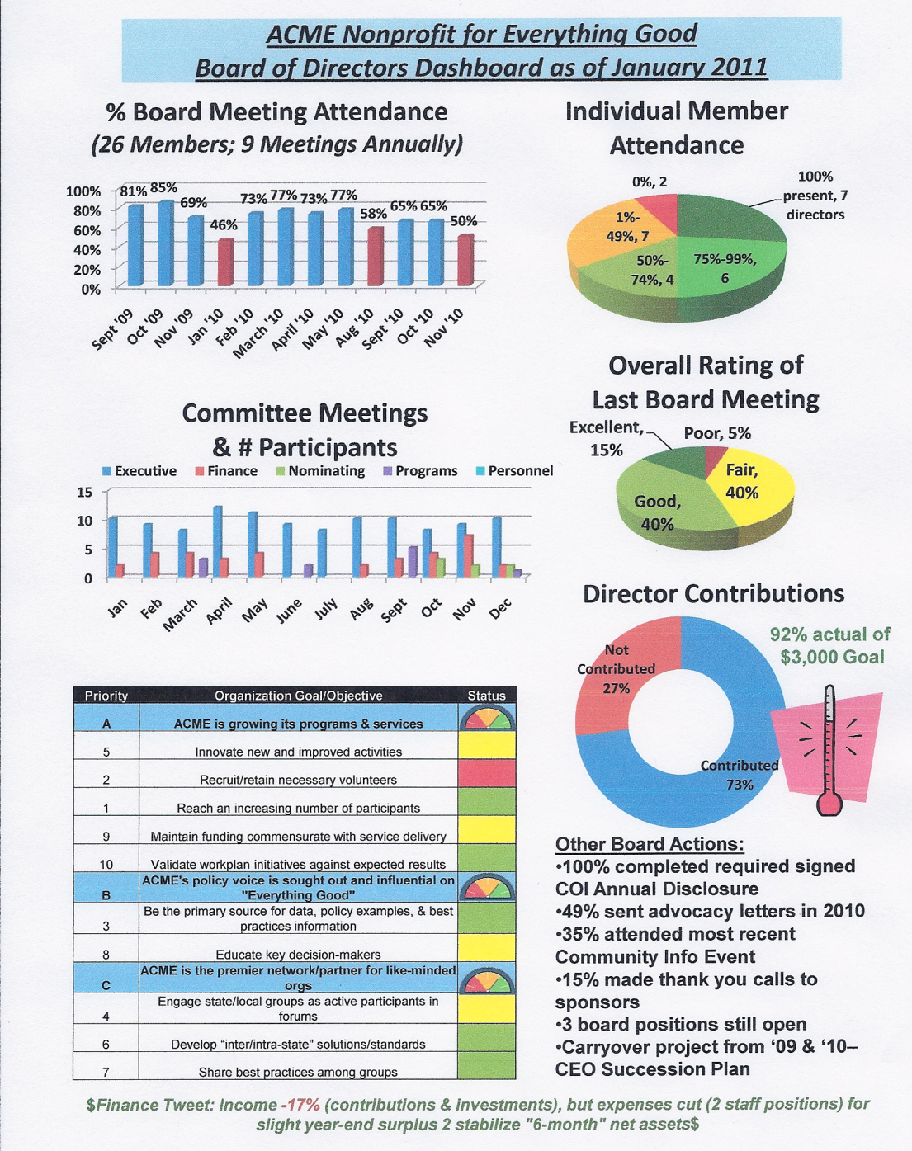
Conflict of Interest Policy
Nonprofits need to have a clear, comprehensive conflict of interest policy that sets the necessary guidelines and protects the organization when a sticky situation gets out of hand. There are three key aspects of a conflict of interest policy.
The first aspect is full disclosure. This means that board members should sign an annual disclosure statement of all relevant professional, business, and personal affiliations possibly affecting their judgment during the year. This makes it easier for the chair to be prepared to handle any situation that arises. Since an annual disclosure statement cannot cover all potential conflicts, board members are expected to step forward and disclose their connections to an issue, and any possible conflicts, while the issue is being discussed by the board.

The second aspect is Recusal and requires board members that have a conflict of interest with an agenda item should recuse themselves and leave the room during the board’s deliberation. This frees the rest of the board to make comments without having to weigh their words or feel uncomfortable about not choosing to back up their colleague.

The third aspect is Resignation. Resignation from the board is the ultimate solution to a strong conflict of interest that cannot be remedied by any other means. This happens when a conflict becomes “inherent” or is structural and the only way to deal with it is for the board member to remove himself or herself from the board.
In order to manage conflicts of interest well, the conflict of interest policy should be in writing and the board (and staff) should review the policy regularly. Often people are unaware that their activities are in conflict with the best interests of the nonprofit so a goal for many organizations is to simply raise awareness and cultivate a “culture of candor.”
- Full disclosure
Persons in decision-making roles make known their connection with groups or individuals doing business with a nonprofit. Information provided annually.
- Abstention
Abstain from voting on any actual or potential conflict- of-interest transaction.
- Record
Recusal is noted in the minutes.
Sample Conflict of Interest Policy
- Employees and board members have an obligation to conduct business within guidelines that prohibit actual or potential conflicts of interest. This policy establishes only the framework within which XYZ wishes its business to operate. The purpose of these guidelines is to provide general direction so that board members and employees can seek further clarification on issues related to the subject of acceptable standards of operation.
- An actual or potential conflict of interest occurs when a board member or an employee is in a position to influence a decision that may result in personal gain or gain for a relative as a result of XYZ’s business dealings. For the purpose of this policy, a relative is any person who is related by blood or marriage, or whose relationship with the board member or employee is similar to that of persons who are related by blood or marriage.
- No presumption of a conflict is created by the mere existence of a relationship with outside firms. However, if a board member or an employee has any influence on any material business transactions, it is imperative that he or she discloses to an officer of the organization as soon as possible the existence of any actual or potential conflict of interest so that safeguards can be established to protect all parties.
- Personal gain may result not only in cases where a board member, an employee, or a relative has a significant ownership in a firm with which XYZ does business, but also when a board member, an employee, or a relative receives any kickback, bribe, substantial gift, or special consideration as a result of any transaction or business dealings involving XYZ. (From the E-Policy Sampler)

Sample Investment Policy
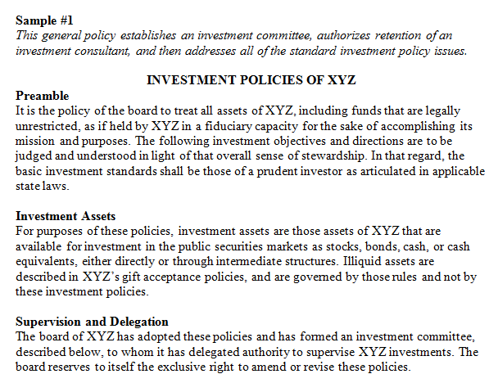
- Investment committee
- Investment consultant, Advisors, and Agents
- Objectives
- Asset allocations
- Rebalancing Procedures
- Investment Guidelines
- Asset Quality
- Asset Diversification
- Proxy Voting
- Custody and Securities Brokerage
- Cash Flow Requirements
- Restrictions
- Mission-based Investment Criteria
- Exceptions to Restrictions
- Reporting Requirements

Sample Investment Policy Continued
Notes
Wise investing provides an opportunity to increase revenues and decrease pressure on fundraising and other sources of revenue. Any organization that has assets to invest should also have appropriate policies to safeguard those investments. Such policies can range from simple introductory statements to complex details useful only to the most sophisticated investment committees.

Key Elements
- A basic investment policy identifies the assets available for investing, defines general investment objectives, sets asset allocation parameters (e.g., diversification), and clarifies the organization’s tolerance for risk (by defining required ratings).
- Investment policies are not only for large organizations with considerable endowments. A responsible board makes sure that policies exist to get the best return from any cash surplus. Likewise, investment policies are reviewed and revised as the organization grows.
- An investment policy often defines the role of an investment manager in day-to-day management of the funds, specifies his or her accountability (e.g., risk in transactions, reporting requirements, and coverage of cash flow needs), and designates a board committee (see E-Policy Sampler: Financial Committees) or the full board to monitor the manager’s performance and that of the portfolio.
- The investment policy offers some protection from liability. By faithfully adhering to the requirements of the investment policy, the board may reduce the chances of arbitrary or inappropriate investments, and thus limit the viability of any charges that it breached fiduciary duties.
- The Uniform Management of Institutional Funds Act (UMIFA) and the Uniform Prudent Investor Act (UPIA) govern the investment of most nonprofit funds and focus on portfolio performance rather than returns on individual transactions. This gives nonprofits greater flexibility in taking reasonable risks with their investments.
Practical Tips
- When determining investment goals, take short-term and long-term goals into consideration. The purpose of the specific fund can help determine the priorities — growth, liquidity, or security — and the level of acceptable risk.
- When diversifying the portfolio, consider different types of investments (e.g., stocks, bonds, alternative and cash equivalents) in different classes (e.g., corporate vs. U.S. Treasury bonds, and large, medium, or small company stocks) in different industries.
- Consider adopting socially responsible investment guidelines, restricting investment activity in liquor, tobacco, arms, and other potentially controversial industries.

Sample Financial Controls Policy
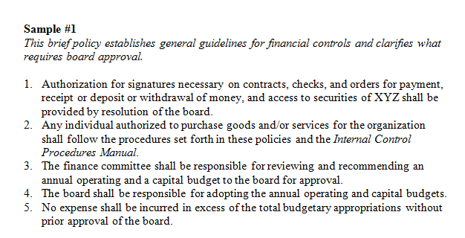

Measuring Programmatic Success Exercise

Questions the Board Should Ask:
- Is this program or service making enough of a difference for the people served?

- Is it cost-effective?

- To what extent is it still needed or wanted?

- Is there a more effective and efficient way to meet the need?

- What is another way to frame the issue we are trying to respond to?

